OBJECT DETECTOR

Submitted by

NAME OF STUDENT ID NUMBER

K. KAVYA REDDY (20R01A04L3)

D. SRIJA (20R01A04K6)

G. VAISHNAVI (20R01A04K8)

G. NARESH KUMAR (20R01A04L0)

G. VINAY (20R01A04K9)

K. MAHIDHAR (20R01A04L4)

SECTION – D BATCH –2 BACHELOR OF TECHNOLOGY

IN

ELECTRONICS AND COMMUNICATION ENGINEERING



CMR INSTITUE OF TECHNOLOGY

**Kandlakoya Village- 501401**

JANUARY - 2022

## TABLE OF CONTENTS

1. Abstract
2. Introduction
3. Hardware System Diagram
4. Components required
5. Working
6. Code
7. Output
8. Applications
9. Conclusions
10. References

## ABSTRACT

Radar is an object detection system which uses radio waves to determine the range, altitude, direction, or speed of objects. It can be used to detect aircraft, ships, spacecraft, guided missiles, motor vehicles, weather formations, and terrain. The radar dish or antenna transmits pulses of radio waves or micro waves which bounce off any object in their path. The object returns a tiny part of the wave's energy to a dish or antenna which is usually located at the same site as the transmitter

The modern uses of radar are highly diverse, including air traffic control, radar astronomy, air-defense systems, antimissile systems; marine radar start locate landmarks and other ships; aircraft anti-collision systems; ocean surveillance systems, outer space surveillance and rendezvous systems; meteorological precipitation monitoring; altimetry and flight control systems; guided missile target locating systems; and ground-penetrating radar for geological observations. High tech radar systems are associated with digital signal processing and are capable of extracting useful information from very high noise levels.

The Arduino based project requires an ultrasonic sensor, the sensor released the waves which we want to measure the distance of an object. The microcontrollers of the Arduino board can be programmed using C and C++ languages. When a code is written in Arduino UNO IDE software and connected to the board through a USB cable, Arduino boards have lot of applications in the present-day scenario, so we have decided to do a small project on them.

## INTRODUCTION

Defining Arduino: An Arduino is actually a microcontroller-based kit which can be either used directly by purchasing from the vendor or can be made at home using the components, owing to its open-source hardware feature. It is basically used in communications and in controlling or operating many devices.

1. Arduino is an open-source electronics platform based on easy-to-use hardware and software. Arduino boards are able to read inputs - light on a sensor, a finger on a button, or a Twitter message - and turn it into an output - activating a motor, turning on an LED, publishing something online. You can tell your board what to do by sending a set of instructions to the microcontroller on the board. To do so you use the Arduino programming language (based on Wiring), and the Arduino Software (IDE), based on Processing.
2. Over the years Arduino has been the brain of thousands of projects, from everyday objects to complex scientific instruments. A worldwide community of makers - students, hobbyists, artists, programmers, and professionals - has gathered around this open-source platform, their contributions have added up to an incredible amount of accessible knowledge that can be of great help to novices and experts alike.
3. Arduino was born at the Ivrea Interaction Design Institute as an easy tool for fast prototyping, aimed at students without a background in electronics and programming. As soon as it reached a wider community, the Arduino board started changing to adapt to new needs and challenges, differentiating its offer from simple 8-bit boards to products for IoT applications, wearable, 3D printing, and embedded environments. All Arduino boards are completely open-source, empowering users to build them independently and eventually adapt them to their particular needs. The software, too, is opensource, and it is growing through the contributions of users worldwide.

ARDUINO UNO

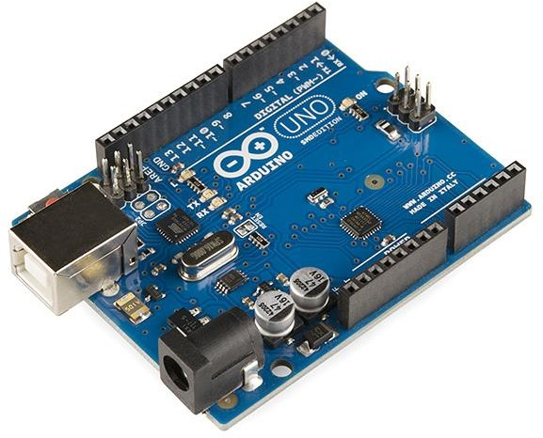

How to program an Arduino?

The Arduino tool window consists of the toolbar with the buttons like verify, upload, new, open, save, serial monitor. It also consists of a text editor to write the code, a message area which displays the feedback like showing the errors, the text console which displays the output and a series of menus like the File, Edit, Tools menu. Thus, the code is uploaded by the bootloader onto the microcontroller.

ULTRASONIC SENSOR

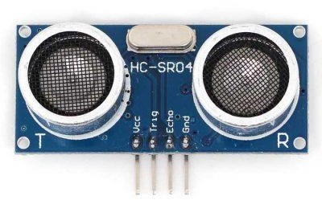

As the name indicates, ultrasonic sensors measure distance by using ultrasonic waves. The sensor head emits an ultrasonic wave and receives the wave reflected back from the target. Ultrasonic Sensors measure the distance to the target by measuring the time between the emission and reception. An optical sensor has a transmitter and receiver, whereas an ultrasonic sensor uses a single ultrasonic element for both emission and reception. In a reflective model ultrasonic sensor, a single oscillator emits and receives ultrasonic waves alternately. This enables miniaturization of the sensor head. Distance calculation

The distance can be calculated with the following formula: Distance L = 1/2 × T × C

Where L is the distance, T is the time between the emission and reception, and C is the sonic speed. (The value is multiplied by 1/2 because it is the time for go-and- return distance.) Features The following list shows typical characteristics enabled by the detection system. [Transparent object detectable]

Since ultrasonic waves can reflect off a glass or liquid surface and return to the sensor head, even transparent targets can be detected.

[Resistant to mist and dirt]

Detection is not affected by accumulation of dust or dirt. [Complex shaped objects detectable]

Presence detection is stable even for targets such as mesh trays or springs.

Processing

All processing is an open-source computer programming language and integrated development environment (IDE) built for the electronic arts, new media art, and visual design communities to teach the fundamentals of computer programming in a visual context. The Specifications of programming:

* Free to download and open source
* Interactive programs with 2D, 3D or PDF output
* OpenGL integration for accelerated 2D and 3D
* For GNU/Linux, Mac OS X, and Windows
* Over 100 libraries extend the core software

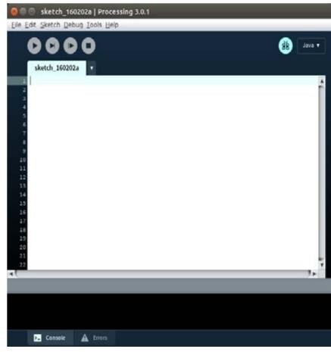

SERVO MOTOR

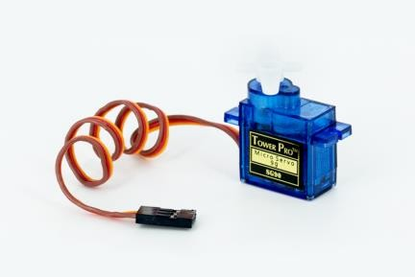

Tiny and lightweight with high output power. The servo will rotate about 180 degrees (90 in each direction) and operate just as small as the regular types. To monitor these services, you can use any servo code, hardware or library [4].

The Specifications of servo motor

* Weight: 9 g
* Dimension: 22.2 x 11.8 x 31 mm approx.
* Stall torque: 1.8 kg f cm
* Operating speed: 0.1 s/60 degree
* Operating voltage: 4.8 V (~5V)
* Temperature range: 0 ºC – 55 ºC

The interfacing between the PC and the Arduino is done by RS232 USB. The Arduino receives the data from the ultrasonic sensor and process it. In the Arduino software, equation (1) is used to calculate the object distance. Also, the position angle of radar is calculated and controlled from the Arduino program. The Arduino sends these data, which are the angle position and the object distance to processing software to show them on the radar screen. The design of hardware that was designed with a scraper environment. The connection of different electronic components is displayed.

# HARDWARE SYSTEM DIAGRAM:

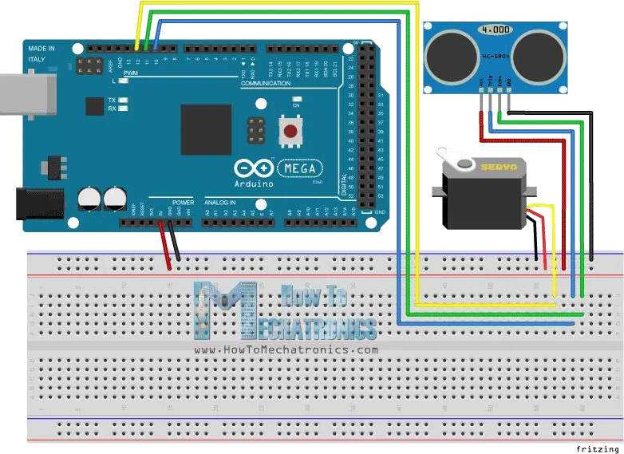

**COMPONENTS REQUIRED:**

In this project we have used the Arduino and ultrasonic sensor along with the jumping wires and the relay motors and details list of the hard ware components are

* Arduino board and Arduino cable

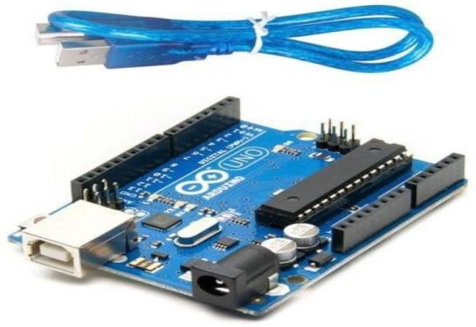

* Jumper wires

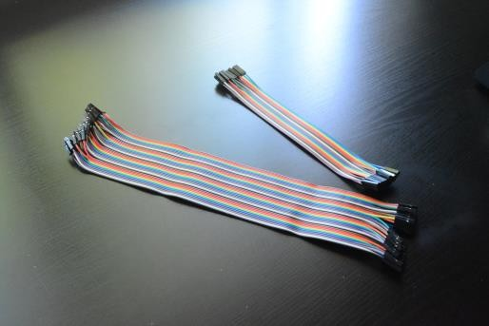

Ultrasonic sensor

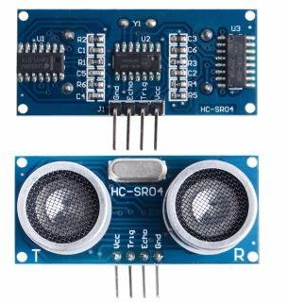

* + Servo motor

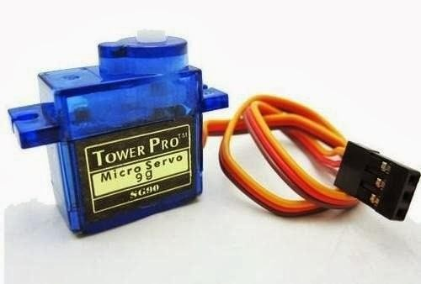

* + Double side plaster

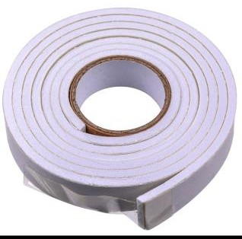

* + Laptop

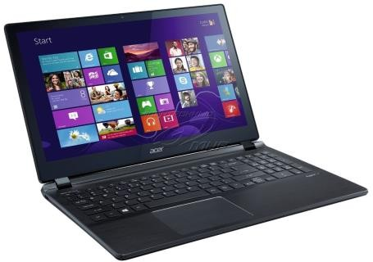

# WORKING

**PRACTICAL IMPLEMENTATION**

* 1. Making on Arduino board:

Since, we believe in learning by doing. So, we decided to make our own Arduino board instead of using the readymade board. So, the steps required to make an Arduino board are as follows: Boot-loading an Atmega328 using the Arduino board/AVR Programmer by uploading the boot loader to the Microcontroller.

Making the connections on Arduino board.

Providing the power supply, usually 5 volts. Arduino is Ready to use.

After you have done all this the same circuit can be made on the PCB, either designed or general purpose. Since, Arduino is an Open-Source. Hence, it is easy to make and can have any enhancements as per the requirements.

* 1. Connecting Servo Motor:

A servomotor is a rotary actuator that allows for precise control of angular position, velocity and acceleration.

A normal servo motor has three terminals:

1. VCC
2. GND
3. PULSE

A servo motor works at normally 4.8 to 6 volts. Ground is provided by connecting it to the Ground of the Arduino. The total time for a servo motor pulse is usually 20ms. To move it to one end of say 0-degree angle, a 1ms pulse is used and to move it to other end i.e., 180 degrees, a 2ms pulse is applied. Hence, according to this to move the axis of the servo motor to the center, a pulse of time 1.5 ms should be applied. For this, the pulse wire of the servo motor is connected to the Arduino that provides the digital pulses for pulse width modulation of the pulse. Hence, by programming for a particular pulse interval the servo motor can be controlled easily.

* 1. Connecting Ultrasonic Sensor :

An Ultrasonic Sensor consists of three wires. One for Vcc , second for Ground and the third for pulse signal. The ultrasonic sensor is mounted on the servo motor and both of them further connected to the Arduino board. The ultrasonic sensor uses the reflection principle for its working. When connected to the Arduino, the Arduino provides the pulse signal to the ultrasonic sensor which then sends the ultrasonic wave in forward direction. Hence, whenever there is any obstacle detected or present in front, it reflects the waves which are received by the ultrasonic sensor.

If detected, the signal is sent to the Arduino and hence to the PC/laptop to the processing software that shows the presence of the obstacle on the rotating RADAR screen with distance and the angle at which it has been detected.5

* 1. Using Processing Software :



Processing is an open-source programming language and integrated development environment (IDE) built for the electronic arts, new media art, and visual design communities with the purpose of teaching the fundamentals of computer programming in a visual context, and to serve as the foundation for electronic sketchbooks. The project was initiated in 2001 by Casey Reas and Benjamin Fry, both formerly of the Aesthetics and Computation Group at the MIT Media Lab. One of the stated aims of Processing is to act as a tool to get non-programmers started with programming, through the instant gratification of visual feedback. The language builds on the Java language, but uses a simplified syntax and graphics programming models.

## ARDUINO SOFTWARE:



Includes the Servo library

# ARDUINO CODE

#include .<Servo.h> // Defines Tirg and Echo pins of the Ultrasonic Sensor const int trigPin = 10;

const int echoPin = 11; // Variables for the duration and the distance long duration;

int distance;

Servo myServo; // Creates a servo object for controlling the servo motor void setup() {

pinMode(trigPin, OUTPUT); // Sets the trigPin as an Output pinMode(echoPin, INPUT); // Sets the echoPin as an Input Serial.begin(9600);

myServo.attach(12); // Defines on which pin is the servo motor attached

}

void loop() { // rotates the servo motor from 15 to 165 degrees for(int i=15;i<=165;i++){

myServo.write(i);

delay(30);

distance = calculateDistance(); // Calls a function for calculating the distance measured by the Ultrasonic sensor for each degree

Serial.print(i); // Sends the current degree into the Serial Port

Serial.print(","); // Sends addition character right next to the previous value needed later in the Processing IDE for indexing

Serial.print(distance); // Sends the distance value into the Serial Port Serial.print("."); // Sends addition character right next to the previous value needed later in the Processing IDE for indexing

} // Repeats the previous lines from 165 to 15 degrees for(int i=165;i>15;i--){

myServo.write(i); delay(30);

xx distance = calculateDistance(); Serial.print(i);

Serial.print(","); Serial.print(distance); Serial.print(".");

}

}

// Function for calculating the distance measured by the Ultrasonic sensor int calculateDistance(){

digitalWrite(trigPin, LOW);

delayMicroseconds(2); // Sets the trigPin on HIGH state for 10 micro seconds digitalWrite(trigPin, HIGH);

delayMicroseconds(10); digitalWrite(trigPin, LOW);

duration = pulseIn(echoPin, HIGH); // Reads the echoPin, returns the sound wave travel time in microseconds distance= duration*0.034/2;

return distance;

}

# PROCESSOR CODE:

import processing.serial.*; // imports library for serial communication

import java.awt.event.KeyEvent; // imports library for reading the data from the serial port import java.io.IOException;

Serial myPort; // defines Object Serial

// defubes variables String angle=""; String distance=""; String data=""; String noObject; float pixsDistance; int iAngle, iDistance; int index1=0;

int index2=0; PFont orcFont; **void setup**() {

size (1200, 700); // ***CHANGE THIS TO YOUR SCREEN RESOLUTION***

smooth();

myPort = **new** Serial(this,"COM5", 9600); // starts the serial communication

myPort.bufferUntil('.'); // reads the data from the serial port up to the character '.'. So actually it reads this: angle,distance.

}

**void draw**() {

fill(98,245,31); // simulating motion blur and slow fade of the moving line noStroke();

fill(0,4);

rect(0, 0, width, height-height*0.065);

fill(98,245,31); // green color

// calls the functions for drawing the radar

**drawRadar**(); **drawLine**(); **drawObject**(); **drawText**();

}

**void serialEvent** (Serial myPort) { // starts reading data from the Serial Port // reads the data from the Serial Port up to the character '.' and puts it into the String variable "data".

data = myPort.readStringUntil('.');

data = data.substring(0,data.length()-1);

index1 = data.indexOf(","); // find the character ',' and puts it into the variable "index1"

angle= data.substring(0, index1); // read the data from position "0" to position of the variable index1 or thats the value of the angle the Arduino Board sent into the Serial Port

distance= data.substring(index1+1, data.length()); // read the data from position "index1" to the end of the data pr thats the value of the distance

// converts the String variables into Integer iAngle = int(angle);

iDistance = int(distance);

}

**void drawRadar**() { pushMatrix();

translate(width/2,height-height*0.074); // moves the starting coordinats to new location noFill();

strokeWeight(2); stroke(98,245,31);

// draws the arc lines

arc(0,0,(width-width*0.0625),(width-width*0.0625),PI,TWO_PI); arc(0,0,(width-width*0.27),(width-width*0.27),PI,TWO_PI); arc(0,0,(width-width*0.479),(width-width*0.479),PI,TWO_PI); arc(0,0,(width-width*0.687),(width-width*0.687),PI,TWO_PI);

// draws the angle lines

line(-width/2,0,width/2,0);

line(0,0,(-width/2)*cos(radians(30)),(-width/2)*sin(radians(30)));

line(0,0,(-width/2)*cos(radians(60)),(-width/2)*sin(radians(60)));

line(0,0,(-width/2)*cos(radians(90)),(-width/2)*sin(radians(90))); line(0,0,(-width/2)*cos(radians(120)),(-width/2)*sin(radians(120))); line(0,0,(-width/2)*cos(radians(150)),(-width/2)*sin(radians(150))); line((-width/2)*cos(radians(30)),0,width/2,0);

popMatrix();

}

**void drawObject**() { pushMatrix();

translate(width/2,height-height*0.074); // moves the starting coordinats to new location strokeWeight(9);

stroke(255,10,10); // red color

pixsDistance = iDistance*((height-height*0.1666)*0.025); // covers the distance from the sensor from cm to pixels

// limiting the range to 40 cms

**if**(iDistance<40){ // draws the object according to the angle and the distance

line(pixsDistance*cos(radians(iAngle)),-pixsDistance*sin(radians(iAngle)),(width- width*0.505)*cos(radians(iAngle)),-(width-width*0.505)*sin(radians(iAngle)));

**void drawLine**() { pushMatrix(); strokeWeight(9); stroke(30,250,60);

translate(width/2,height-height*0.074); // moves the starting coordinats to new location

line(0,0,(height-height*0.12)*cos(radians(iAngle)),-(height-height*0.12)*sin(radians(iAngle))); // draws the line according to the angle

popMatrix();

}

**void drawText**() { // draws the texts on the screen pushMatrix();

**if**(iDistance>40) {

noObject = "Out of Range";

}

**else** {

noObject = "In Range";

}

fill(0,0,0); noStroke();

rect(0, height-height*0.0648, width, height); fill(98,245,31);

textSize(25);

text("10cm",width-width*0.3854,height-height*0.0833); text("20cm",width-width*0.281,height-height*0.0833); text("30cm",width-width*0.177,height-height*0.0833); text("40cm",width-width*0.0729,height-height*0.0833); textSize(40);

text("Robu.in", width-width*0.875, height-height*0.0277);

text("Angle: " + iAngle +" °", width-width*0.48, height-height*0.0277); text("Distance: ", width-width*0.26, height-height*0.0277); **if**(iDistance<40) {

text(" " + iDistance +" cm", width-width*0.225, height-height*0.0277);

}

textSize(25); fill(98,245,60);

translate((width-width*0.4994)+width/2*cos(radians(30)),(height-height*0.0907)- width/2*sin(radians(30)));

rotate(-radians(-60));

text("30°",0,0);

resetMatrix();

translate((width-width*0.503)+width/2*cos(radians(60)),(height-height*0.0888)- width/2*sin(radians(60)));

rotate(-radians(-30));

text("60°",0,0);

resetMatrix();

translate((width-width*0.507)+width/2*cos(radians(90)),(height-height*0.0833)- width/2*sin(radians(90)));

rotate(radians(0)); text("90°",0,0);

resetMatrix();

translate(width-width*0.513+width/2*cos(radians(120)),(height-height*0.07129)- width/2*sin(radians(120)));

rotate(radians(-30)); text("120°",0,0);

resetMatrix();

translate((width-width*0.5104)+width/2*cos(radians(150)),(height-height*0.0574)- width/2*sin(radians(150)));

rotate(radians(-60)); text("150°",0,0);

popMatrix();

}

**APPLICATIONS:**

The radar system is used mostly for mapping and has several uses for protection purposes

* Application in Air Force:

This is used for the identification of items that come in by aeroplans or aircraft devices that have a radar device in it. It is often used for the height measurement calculation.

* Application in Marine

It is also used in ships or in marine applications. The distance of other boats or ships is measured on big ships and can be minimized by not colliding with the aid of this sea accident. It can also be used at ports to see the distance from other vessels and track or monitor the movements of the vessels

* Application In Meteorology:

Wind tracking or monitoring is also done with radar systems. It has become a major climate monitoring equipment. For starters, storms are used to detect tornados.

Improvised accuracy: The resistors with low value in milliohms are used in advanced cars with sensitive power steering and break circuits. Now a days these advancements have become the major cause for the severe accidents. Therefore, the components used in such circuits must have accurate and precise value for smooth working of such circuits. Ultimately this refers to the accurate testing of the resistors used. Improvised accuracy is thus the second primary aim of the sensor.

# CONCLUSION:

***This project aims on the use of Ultrasonic Sensor by connected to the Arduino UNO R3 board and the signal from the sensor further provided to the screen formed on the laptop to measure the presence of any obstacle in front of the sensor as well as determine the range and angle at which the obstacle is detected by the sensor.***

1. <http://www.arduino.cc/>

# REFERENCES:

1. http://www.arduinoproducts .cc/
2. <http://www.atmel.com/atmega328/>
3. http://en.wikipedia.org/wiki/File:16MHZ_Crystal.jpg [5]

http://www.google.co.in/imgres?imgurl=<http://www.electrosome.com/wpcontent/uploa> ds/2012/06/ServoMotor.gif&imgrefurl=<http://www.electrosome.com/tag/se>rvo motor/&h=405&w=458&sz=67&tbnid=rcdlwDVt_x0DdM:&tbnh=100&tbnw=113&zoo m=1 &usg= 6J2h0ZocdoSMrS1qgK1I2qpTQSI=&docid=lEfbDrEzDBfzbM&sa=X&ei=a_ OKU vTbD8O5rgeYv4DoDQ&ved=0CDwQ9QE

1. http//: [www.sproboticworks.com/ic%20pin%20configuration/7805/Pinout.jpg/](http://www.sproboticworks.com/ic%20pin%20configuration/7805/Pinout.jpg/)
2. [http://www.sproboticworks.com/ic%ultrasonicsensor%20pinout.jpg](http://www.sproboticworks.com/ic%25ultrasonicsensor%20pinout.jpg)
3. <http://www.instructables.com/id/>ATMega328-using-Arduino-/
4. <http://www.motherjones.com/files/blog_google_driverless_car.jpg>
5. [http://www.google.co.in/imgres/Radar_antenna.jpg&w=546&h=697&ei=wuuK](http://www.google.co.in/imgres/Radar_antenna.jpg%26w%3D546%26h%3D697%26ei%3DwuuK)
6. <http://www.radomes.org/museum/photos/equip/ANSPS17.jpg>